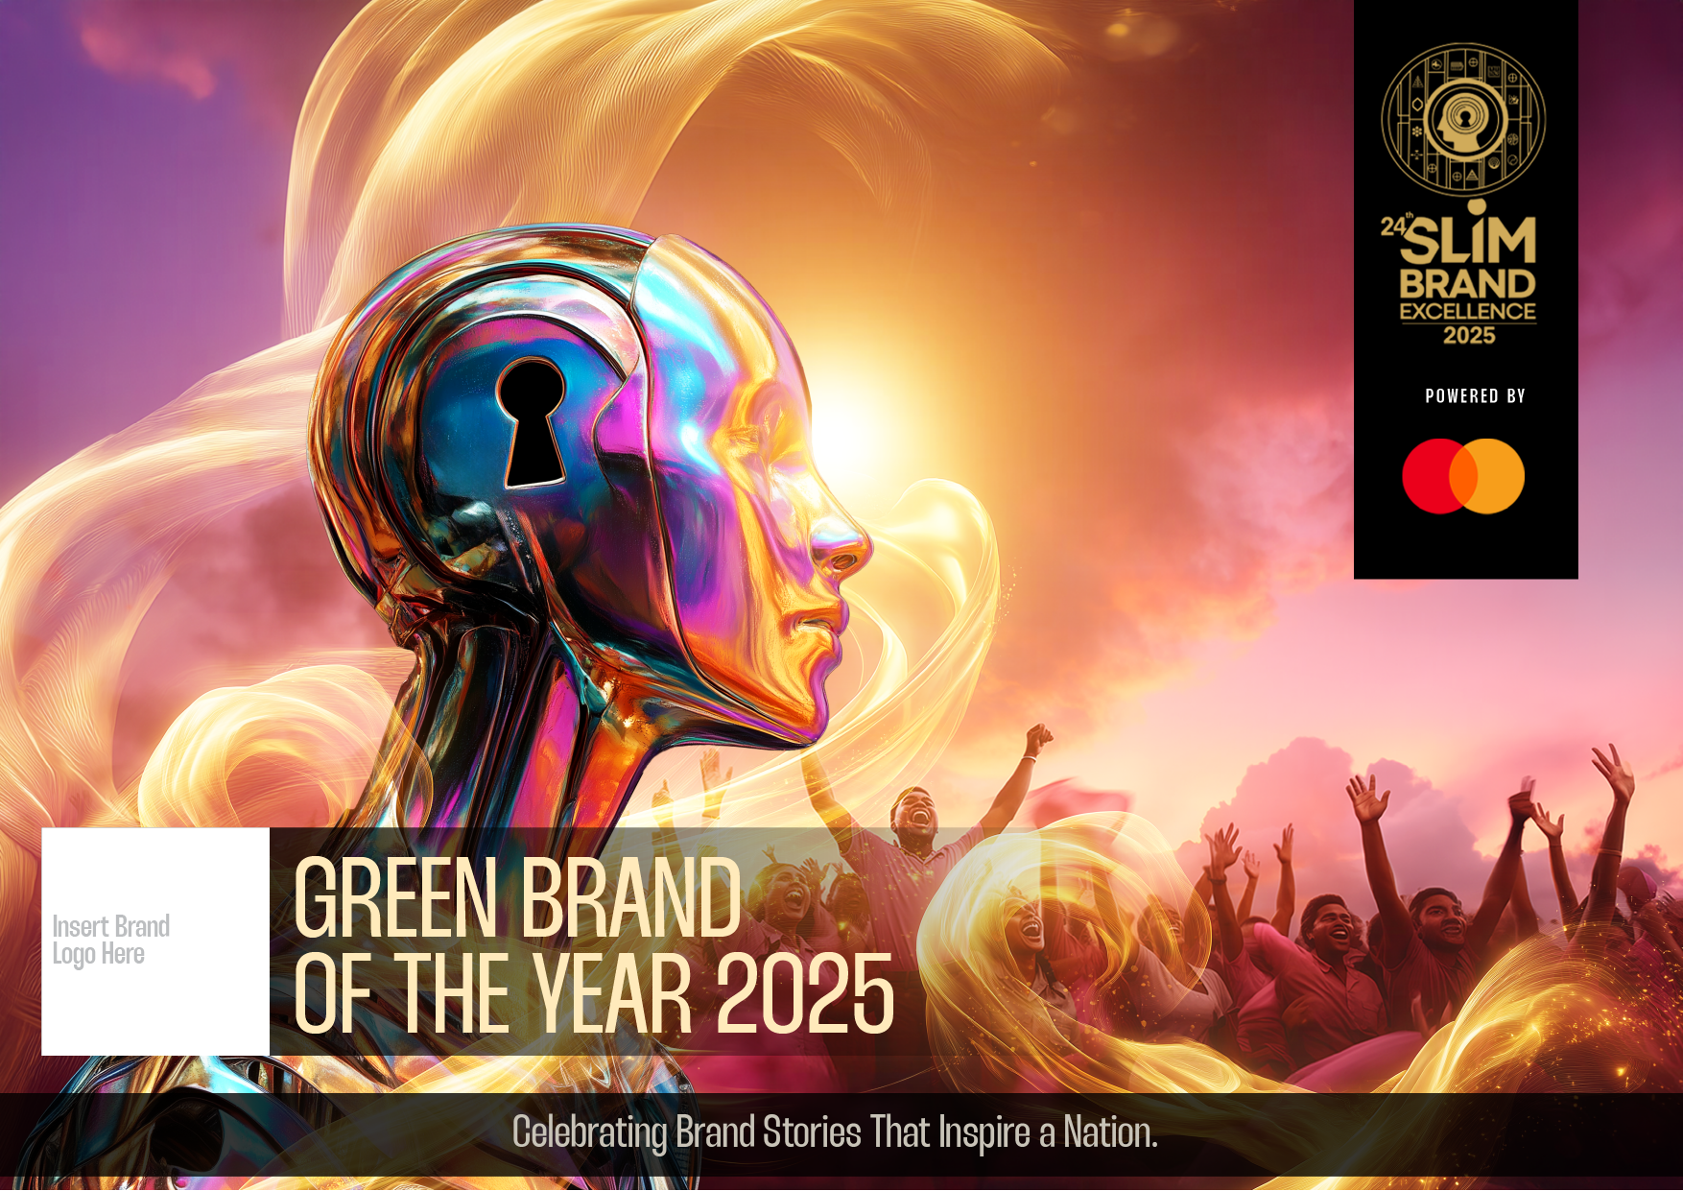
INSTRUCTIONS TO PARTICIPANTS

- Please stick to the format when responding to the questions in the entry form and ensure that you strictly adhere to the provided space allocation. (Within the box)

- Please ensure to use a font size above 10 when completing your entries.

- Please attach visuals and supporting documentation separately.

- Please ensure to include all internal company information to showcase achievements and all research information should be verified by auditors and the research agency on the last page of your entry. In addition, verification seals should be placed on the document on which data is provided.

- The complete application should not exceed 5 pages. (Excluding attachments)

- All data contained in the application must reflect a single period, either the calendar year (Jan to Dec 2024) or the financial year (1st April 2024 to 31st March 2025), shorter periods will not be accepted.

- External data such as market share, equity scores must include competitor data for comparison.

- All data submitted in the application must relate to the brand under which the application is made.
Example:
- If the brand the submission is made on behalf is “Prius” (SUB BRAND) all data and activities included in the application must relate to “Prius” (SUB BRAND) specifically and not any activities, results or data related to Toyota (CORPORATE OR MAIN BRAND).
- If the application is made for “Toyota” (CORPORATE OR MAIN BRAND), all data and activities included in the application must relate to “Toyota” (CORPORATE OR MAIN BRAND) specifically and not any activities, results or data related to their sub-brands such as Prius or Corolla.
GREEN BRAND OF THE YEAR

We are concerned with environmental issues now more than ever. Air pollution, plastic in oceans, global warming, and food waste all are among the major threats, making us worry and think of being kinder to the planet. In support of environmental health, millions have begun purchasing socially responsible products despite their higher cost. This award aspired to recognize Brands who can illustrate how they change their missions and practices from reclusively revenue-driven to balancing commercial aspirations whilst being environmentally aware thru business processes that have the least impact on the environment as possible.

Note: Brand Book not required for this category.

•A.1: Name and Address of Company:  •A.2: Year of Establishment of Company:  •A.3: Size of Company:  (Please mark your selection with a “X” within brackets)  ( )XS - Annual turnover Less than Rs.100 mill  ( )S - Annual Rs.101 mill - Rs.500 mill  ( ) M - Annual Rs.500 mill – Rs.2 bill  ( ) L - Annual turnover Rs.2 bill – Rs.5 bill  ( ) XL - Annual turnover more than Rs.5 bill |  | •B.1: Name of Brand:  •B.2:Year of launch of the brand into the Sri Lankan market  •B.3: Entry Category  (specify from Main Awards or Special Awards Category)* :  •B.4: Origin of Brand : 1 – Sri Lanka 2 – International  •B.4: Size of Brand :  ( Please mark your selection with a “X” within brackets)  ( ) XXS - Annual turnover Less than Rs.50 mill  ( ) XS - Annual turnover Rs.51 mill – Rs.100 mill  ( ) S - Annual turnover Rs.101 mill – Rs.250 mill  ( ) M - Annual turnover Rs.251 mill – Rs.500 mill  ( ) L - Annual turnover Rs.5001 – Rs.1 bill  ( ) XL - Annual turnover Rs.1 bill – Rs.5 bill  ( ) XXL - Annual turnover more than Rs.5 bill

Brand Process- 40% - AWARDS CATEGORY SPECIFIC QUESTIONS
1. Green Vision for the brand. Explain what Social and or Economic and or Environmental impact the brand aspires to achieve and why? (Please use only space given in the box)Font size not below

2. Explain what business processes that we redesigned to minimize the impact on the environment keeping in mind both social and economic impact. (Please use only space given in the box) Font size not below 10

3. Illustrate the impact of the initiatives in terms of Social and or Economic Impact and or Environment Impact. Tie in where relevant to the (SDGs) Sustainable development goals where relevant. (Please use only space given in the box) Font size not below 10.

4. How were the brands green initiates incorporated to the brand proposition’s both the brand communications as well as the total value chain. (Please use only space given in the box) Font size not below 10.

5. Using either brand equity studies or other feedback methodology illustrate how the brand green approach has positively impacted the brands perception among employees, suppliers, investors and consumers/customers. (Please use only space given in the box) Font size not below 10.

BRAND PERFORMANCE (40%)

In this section the actual performance of the brand in the market place will be assessed through the information provided by you in the application, which will be endorsed by independent auditors and research companies.

Marks in this section will be apportioned as follows;

A) Brand Health (20%)
A.1. Provide information with regard to brand equity measures; brand awareness, brand associations, loyalty, customer satisfaction etc. endorsed by research companies. (Font size not below 10)
Note: Wherever research data is presented to show a particular brand’s performance it should be substantiated by clearly stating the source duly verified by the researcher and performance should be compared against industry. For research data, please follow the research guidelines mentioned in the website/ handout provided.

B) Business Performance of the Brand (20%)

Provide information with regard to sales value growth, sales volume growth, market share growth, profit / contribution over the last 3 years (Please use only space given in the box) Data has to be supported by audit confirmation and seal placement on each submission. Please fill ALL spaces in the tables below

B.1. Carbon Footprint
Results | 2022/2023 or 2022 (Index) | 2023/2024 or 2023 (Index) | 2024/2025 or 2024  (Index)
Carbon Footprint | 100
Source of information:
Comments:

B.2. Revenue Index & Percentage
Results | 2022/2023 or 2022 (Index & Percentage) | 2023/2024 or 2023 (Index & Percentage) | 2024/2025 or 2024 (Index & Percentage)
Revenue (Index) | 100
Revenue (%)
Source of Information:
Comments:

B.3. Market Share Index & Percentage
Results | 2022/2023 or 2022 (Index & Percentage) | 2023/2024 or 2023 (Index & Percentage) | 2024/2025 or 2024 (Index & Percentage)
Market Share (Index) | 100
Market Share (%)
Source of Information:
Comments:

Applicant’s Declaration
I, the undersigned ……………………………………………………………………………………………………… (Full name of applicant) do hereby declare and affirm that all information herein provided by me is true and correct.
Name of Applicant:
Designation of Applicant:
Contact Number: E-mail:
Signature of applicant: Date:
Company name & address
V.A.T Reg. No:
Name of CEO of Company:
Signature of CEO: Date:
Contact Details: Rubber Stamp:
Telephone: Fax: E-mail:
Auditor’s Verification
We hereby certify that all information herein furnished in items …………………………………….. (Indicate information section numbers) in the entry form in respect of …………………………….. Is true and correct to the best our knowledge and belief, as per the records maintained by the enterprise and made available for scrutiny.
Name of Auditor: Rubber stamp:
Signature:
Contact details:
Address:
Telephone: Fax:
Independent Research Verification
We hereby certify that all information herein furnished in items …………………………… (Indicate information section numbers) ………………………. in the entry form in the respect of ………………………….. is true and correct as per the research findings of studies conducted by this agency and fulfill the criteria for research findings that can be submitted for this entry.
Name of Agency: Rubber stamp:
Signature:
Contact Details:
Address:
Telephone: Fax: E-mail:
Note: If more than one auditor’s and/or research agency information is used please use copies of this page for each one of those institutions.
-END-

