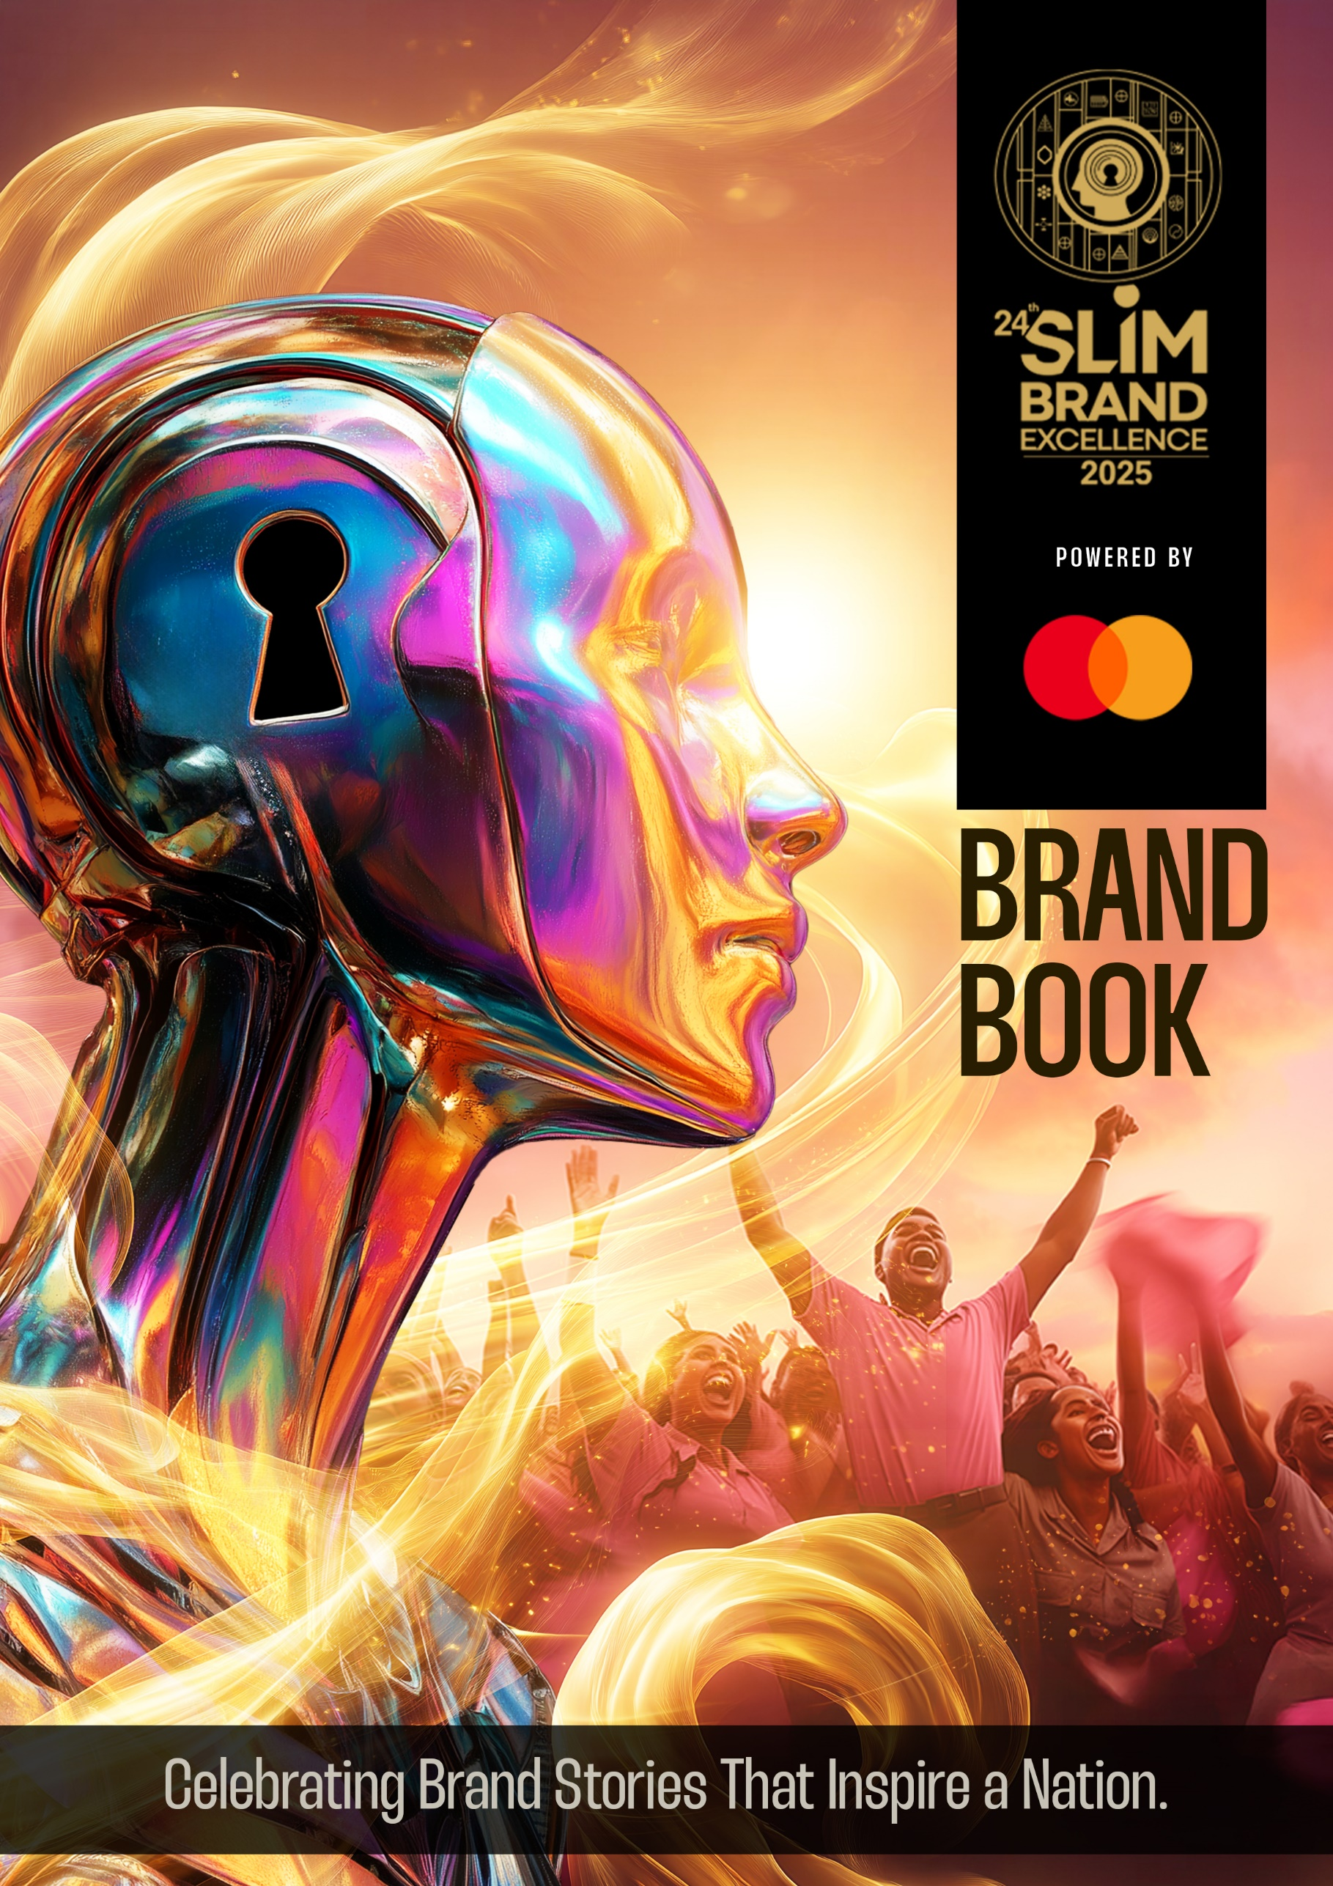

# The Brand Book

***“The art of marketing is the art of brand building. If you’re not a brand, you are a commodity. Then price is everything and the low-cost producer is the only winner”***

- **Philip Kotler -**

It is not just talk, but actions and the results of many great brands out there that were built scientifically that withstand the great test of time and change that show us just how important it is to craft your brand. The brand book is dedicated to understanding how well your brand has been crafted.

Come tell us your brand story.

Note: Each brand is only required to fill the brand book once even if you’re applying for multiple categories.

# Background

Describe the relevant market category/industry and competitive structure which represent your brand, (you may use frameworks such as the five forces model.) This will help understand the context within which your brand operates.

Please use only space given in the box. Font size not below 10.

# (A) BRAND INTENT (10%)

In this section, the applicants will describe the strategic intent of the brand in order to help the judges to appreciate the overall direction in which the brand is intended to move.

A.1. Brand Purpose (Please use only space given in the box)

The positive impact a brand has in a consumers’ life and the world they live in. Font size not below 10.

A.2. Brand Target (Market) (Please use only space given in the box) Font size not below 10. What is the profile of the typical consumer? Describe vividly. Do not confine it only to demographics.

A.3. Brand Vision (Please use only space given in the box)

What are the brand’s long and medium term objectives? Font size not below 10.

A. 4. Brand Mission (Please use only space given in the box)

What are the intended principal tasks to accomplish its vision? Font size not below 10.

A. 5. Brand Lifecycle (Please use only space given in the box)

Where is the brand placed in the lifecycle? And what are its related strategies? Font size not below 10.

A. 6. What is the brand’s naming strategy and why? (Please use only space given in the box) (Umbrella / Monolithic vs. Individual / Discreet vs. Hybrid / Sub brands) You may use any visual aid to demonstrate this- or any other approach used by your company. Font size not below 10.

# B) BRAND CONTENT (10%)

This section will deal with what the brand is about, in terms of its values and imagery.

B. 1. Brand Values (Please use only space given in the box)

What are the core values, the brand upholds and how are they promoted within the company? Font size not below 10.

1. 2. Brand Personality (Please use only space given in the box)

How is the brand perceived in terms of personality attributes? Font size not below 10.

B.3. Brand Reflection (Please use only space given in the box)

What image does it want to project of the users / clients of the brand? Font size not below 10.

# BRAND PROCESS (40%)

This section will address specific branding strategies that have been adopted by the applicants, in order to make the target consumers value and internalize the brand and its key elements.

C.1. What is the brand’s value proposition vis-a-vis competition and why?

(Please use only space given in the box) (eg: “more value for a higher price”) Font size not below10.

C.2. What is/ are the point(s) of difference between the brand and those in the category and how credible is it? How does the POD create value for the consumer?

(Please use only space given in the box) Font size not below 10.

C.3. How distinctive, defensible and deliverable is the POD?

(Please use only space given in the box) Font size not below 10.

C4. How is the brand recalled in the consumer’s mind? And why is this strategic?

(Names and distinctive marks). (Please use only space given in the box)

You may attach any visual aid to demonstrate this. Font size not below 10.