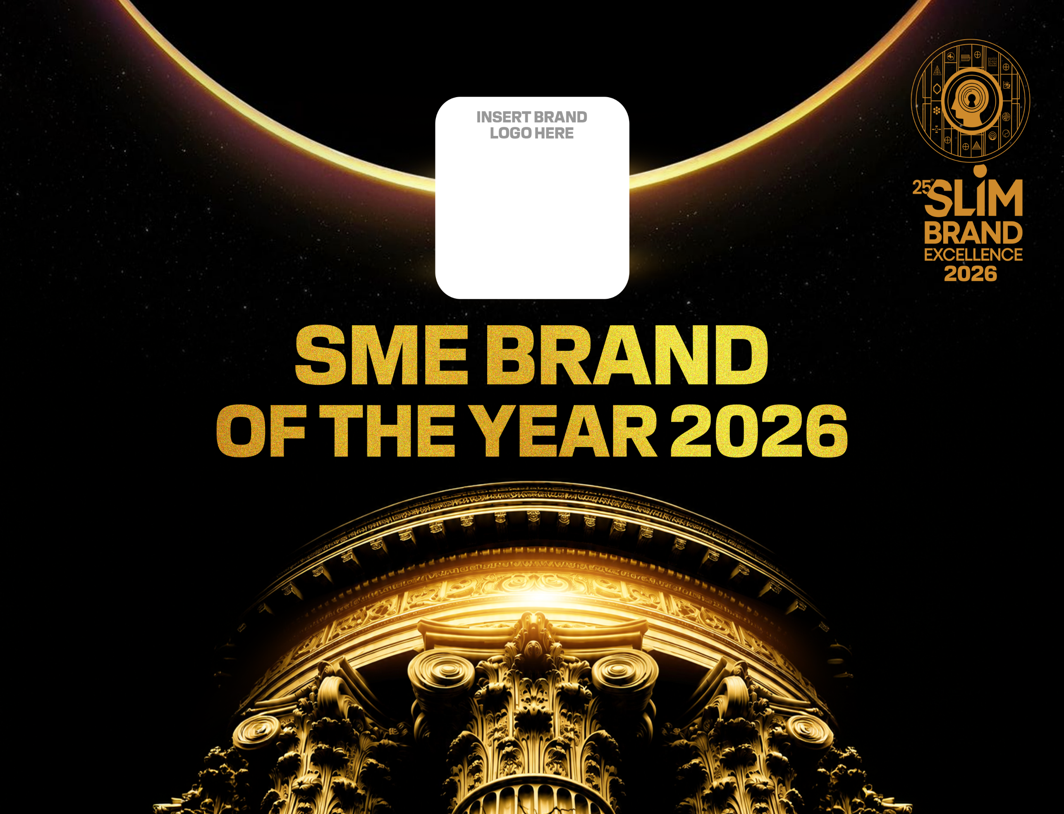
INSTRUCTIONS TO PARTICIPANTS

- Please use only this format for responses to the questions in this entry form adhering strictly to the space allocation (given box).

- Please type your entries in font size not below 10.

- Please attach visuals and supporting documentation separately.

- Please ensure all internal company information to show achievement and all research information be verified by auditors and the research agency on the last page of your entry. In addition, verification seals should be placed on the document on which data is provided.

•A.1: Name and Address of Company:  •A.2: Year of Establishment of Company:  •A.3: Size of Company:  (Please mark your selection with a “X” within brackets)  ( )XS - Annual turnover Less than Rs.350 mill  ( )S - Annual Rs.351 mill - Rs. 1 bill  •A.4: Financial Year:  (Please mark your selection with a “X” within brackets)  ( ) January – December  ( ) April – March |  | •B.1: Name of Brand:  •B.2: Brand Custodians Name & Designations:  •B.3: Year of launch of the brand into the Sri Lankan market  •B.4: Entry Category  (specify from Main Awards or Special Awards Category)* :  •B.5: Origin of Brand : 1 – Sri Lanka 2 – International  •B.6: Size of Brand :  ( Please mark your selection with a “X” within brackets)  ( ) XXS - Annual turnover Less than Rs.20 mill  ( ) XS - Annual turnover Rs.21 mill – Rs.350 mill  ( ) S - Annual turnover Rs.351 mill – Rs.1 bill  ( ) M - Annual turnover Rs. 1 bill – Rs.2 bill

Describe the relevant market/industry and competitive structure which represent your Business *power of supplier * Power of buyer *Threat of new entry * threat if substitution (five forces model.) This will help understand the context within which your brand operates.

Please use only space given in the box. Font size not below 10.

C.1. SEGMENTATION AND TARGETING (25%)

C.1.1. What was the business opportunity identified and how was it done? (half A4) Font size not below 10

C.1.2. Before the introduction of your product, what did customers/consumers use to fill the need?
(half A4) Font size not below 10

C.1.3. Describe your customer/consumer. (half A4) Font size not below 10

C.1.4. Why did you pick on the above group of customers/consumers? (half A4) Font size not below 10

C.2. POSITIONING (20%)
C.2.1. How did you decide on your brand name? (half A4) Font size not below 10
C.2.2. What do you want your customers / consumers to understand from your brand name (half A4)
Font size not below 10

C.2.3. Why should your customers / consumers buy your brand instead of other competing brands (what is different / superior in your brand) (half A4) Font size not below 10

C.3. BRAND PROCESS (40%)
C.3.1. How is the Marketing Mix used to generate business for the brand – (describe each element – Product, Price, Place and Promotion) (2 A4 sheets) Font size not below 10

C.4. BRAND PERFORMANCE (15%)

In this section the actual performance of the brand in the market place will be assessed through the information provided by you in the application, which will be endorsed by independent auditors and research companies.

Marks in this section will be apportioned as follows;

C.4.1. Provide details of customer feedback (Does not require certification from Research Agency). You may use details from Customer Feedback Book / Box / Facebook Fan Page / Letters Written by Customers etc.
Font size not below 10

C.4.2. Sales Performance of the Brand

C.4.2.1. Sales (Index & Percentage)
Results | 2023/2024 or 2023(=100) | 2024/2025 or 2024 (Index & Percentage) | 2025/2026 or 2025 (Index & Percentage) | Estimated Total Sales Value as of 2026
Volume | 100
Source of information:
Comments:
C.4.3 Net Profit of the Brand

C.4.3.1. Net Profit (Index & Percentage)
Results | 2023/2024 or 2023 (=100) | 2024/2025 or 2025 (Index & Percentage) | 2025/2026 or 2026 (Index & Percentage) | Estimated Total Net Profit as of 2026
Sales Value | 100
Source of information:
Comments:

Applicant’s Declaration
I, the undersigned ………………………………..……………………………………………………………………… (Full name of applicant) do hereby declare and affirm that all information herein provided by me is true and correct.
Name of Applicant:
Designation of Applicant:
Contact Number: E-mail:
Signature of applicant: Date:
Company name & address
V.A.T Reg. No:
Name of CEO of Company:
Signature of CEO: Date:
Contact Details: Rubber Stamp:
Telephone: Fax: E-mail:
Auditor’s Verification
We hereby certify that all information herein furnished in items …………………………………….. (Indicate information section numbers) in the entry form in respect of …………………………….. Is true and correct to the best our knowledge and belief, as per the records maintained by the enterprise and made available for scrutiny.
Name of Auditor
Signature:: Rubber stamp:
Contact details:
Address:
Telephone: Fax:
Independent Research Verification
We hereby certify that all information herein furnished in items …………………………… (Indicate information section numbers) ………………………. in the entry form in the respect of ………………………….. is true and correct as per the research findings of studies conducted by this agency and fulfill the criteria for research findings that can be submitted for this entry.
Name of Agency
Signature:: Rubber stamp:
Contact Details:
Address:
Telephone: Fax: E-mail:

Note: If more than one auditor’s and/or research agency information is used please use copies of this page for each one of those institutions.
-END-

