
INSTRUCTIONS TO PARTICIPANTS

- Please stick to the format when responding to the questions in the entry form and ensure that you strictly adhere to the provided space allocation. (Within the box)

- Please ensure to use a font size above 10 when completing your entries.

- Please attach visuals and supporting documentation separately.

- Please ensure to include all internal company information to showcase achievements and all research information should be verified by auditors and the research agency on the last page of your entry. In addition, verification seals should be placed on the document on which data is provided.

- The complete application should not exceed 12 pages. (Excluding attachments)

- For this category, performance data must be provided for 2023/24, 2024/25 and 2025/26 in order to evidence the decline - turnaround - sustained growth journey. All other data must reflect a single period, either the calendar year (Jan to Dec 2025) or the financial year (1st April 2025 to 31st March 2026); shorter periods will not be accepted.

- External data such as market share, equity scores must include competitor data for comparison.

- All data submitted in the application must relate to the brand under which the application is made.
Example:
- If the brand the submission is made on behalf is “Prius” (SUB BRAND) all data and activities included in the application must relate to “Prius” (SUB BRAND) specifically and not any activities, results or data related to Toyota (CORPORATE OR MAIN BRAND).
- If the application is made for “Toyota” (CORPORATE OR MAIN BRAND), all data and activities included in the application must relate to “Toyota” (CORPORATE OR MAIN BRAND) specifically and not any activities, results or data related to their sub-brands such as Prius or Corolla.

TURNAROUND BRAND OF THE YEAR
Entries should be submitted by brands that can evidence a measurable decline in 2023/24, a significant recovery in 2024/25 and sustained improvement in 2025/26

•A.1: Name and Address of Company:  •A.2: Year of Establishment of Company:  •A.3: Size of Company:  (Please mark your selection with a “X” within brackets)  ( )XS - Annual turnover Less than Rs.350 mill  ( )S - Annual Rs.351 mill - Rs. 1 bill  ( ) M - Annual Rs. 1 bill – Rs.2 bill  ( ) L - Annual turnover Rs.2 bill – Rs.5 bill  ( ) XL - Annual turnover more than Rs.5 bill  •A.4: Financial Year:  (Please mark your selection with a “X” within brackets)  ( ) January – December  ( ) April – March |  | •B.1: Name of Brand:  •B.2: Brand Custodians Name & Designations:  •B.3:Year of launch of the brand into the Sri Lankan market  •B.4: Entry Category  (specify from Main Awards or Special Awards Category)* :  •B.5: Origin of Brand : 1 – Sri Lanka 2 – International  •B.6: Size of Brand :  ( Please mark your selection with a “X” within brackets)  ( ) XXS - Annual turnover Less than Rs.20 mill  ( ) XS - Annual turnover Rs.21 mill – Rs.350 mill  ( ) S - Annual turnover Rs.351 mill – Rs.1 bill  ( ) M - Annual turnover Rs. 1 bill – Rs.2 bill  ( ) L - Annual turnover Rs. 2 bill – Rs.5 bill  ( ) XL - Annual turnover more than Rs.5 bill

BRAND PROCESS (40%)

This section will address specific branding strategies that will be adopted by the applicants, in order to make the target consumers, value and internalize the brand, and its key elements (to be submitted together with the completed Brand Book)
C.5.Describe the crisis or downturn you experienced and it’s reasons (Please use only space given in the box) Font size not below 10.
The Challenge
- What was wrong with the brand?

The Turning Point
- What was the key insight that changed the thinking? What did the company discover about consumers, the market or competition?

C.6. Describe the strategies adopted to reverse the crisis and overcome the downturn? (Evidence and information must be provided to substantiate the above. (Please use only space given in the box)
Font size not below 10.
Turnaround Intent
- What did the brand want to achieve? Clear turnaround objectives and ambition.

Turnaround Strategy
- What fundamentally changed in the brand strategy, positioning, target market, proposition or business model?

C.7. How is the brand’s aforesaid strategic positioning operationalized through the elements of the marketing mix? (Please use only space given in the box) Font size not below 10.
Brand Transformation
- What changed in the marketing mix ... product, price, place, promotion, people, digital, experience, packaging etc.?

Execution Process
- How was the turnaround implemented? Key actions, timeline, teams, resources and critical decisions.

C.8. What results did the turnaround deliver, and how sustainable are they? (Please use only space given in the box) Font size not below 10.
Results / Performance
- Evidence that the brand actually turned around .. sales, market share, penetration, profitability, awareness, consideration, loyalty etc.

Sustainability of the Turnaround
- Is the recovery temporary or has the brand established a sustainable platform for future growth?

C.9. Summarise the turnaround journey in the table below (BEFORE / WHAT CHANGED / AFTER), with measurable evidence for each stage? Please clearly demonstrate:
- BEFORE: What challenges was the brand facing? (e.g., declining sales, market share, relevance, consumer perception, distribution, or increasing competition)
- WHAT CHANGED: What strategic actions or changes did the brand implement? (e.g., new consumer insight, positioning, product/service, pricing, channels, communication, customer experience, or business/marketing model)
- AFTER: What measurable results were achieved? (e.g., sales growth, market-share recovery, increased penetration, improved brand health, consumer preference, profitability, or sustainable growth)
Support your response with relevant evidence and measurable results demonstrating the impact of the turnaround.

BRAND PERFORMANCE (40%)

In this section the actual performance of the brand in the market place will be assessed through the information provided by you in the application, which will be endorsed by independent auditors and research companies.

Marks in this section will be apportioned as follows;

- Brand Health (20%)
A.1. Provide information with regard to brand equity measures; brand awareness, brand associations, loyalty, customer satisfaction etc. endorsed by research companies. (Font size not below 10)

Note: Wherever research data is presented to show a particular brand’s performance it should be substantiated by clearly stating the source duly verified by the researcher and performance should be compared against industry. For research data, please follow the research guidelines mentioned in the website/ handout provided.

B) Business Performance of the Brand (20%)

The financial results section has been divided in to different areas in order to recognize the differentiation between different service entities. Please provide relevant information in your respective areas pertaining to the last 3 years (Please use only space given in the box) Data has to be supported by audit confirmation and seal placement on each submission. Please fill ALL spaces in the tables below.

Its MANDATORY that either tables 1/2&3 or 4(for Banks) or 5 (for Insurance companies) or 6(for Finance Companies) are included in the slides presented during the 2nd round.

1. Volumes |  | 2023/2024 or 2023 | 2024/2025or 2024 | 2025/2026or 2025
1.1 | Volume in MT/KG/LT/Units or
1.1 | Volume as an Index 2022/2023 or 2022 = 100 | 100
1.2 | Market (Volume) Share % or
1.2 | Market (Volume) Share as an index 2022/2023 or 2022 = 100 | 100
Indicate Market Share Source, ie: Independent Research/Industry publication/Import-Export Statistics or Internal estimate (Delete accordingly)
2. Value (LKR for Products marketed in Sri Lanka or USD for Exports) |  | 2023/2024 or 2023 | 2024/2025or 2024 | 2025/2026or 2025
2.1 | Value in LKR / USD (mandatory for export brands) or
2.1 | Value as an Index 2022/2023 or 2022 = 100 | 100
2.2 | Market (Value) Share % or
2.2 | Market (Value) Share as an index 2022/2023 or 2022 = 100 | 100
Indicate Market Share Source, ie: Independent Research/Industry publication/Import-Export Statistics or Internal estimate (Delete accordingly)
3. Brand Profitability |  | 2023/2024 or 2023 | 2024/2025or 2024 | 2025/2026or 2025
3.1 | Gross profit/margin in LKR/USD (Absolute terms) or
3.1 | GP as an Index 2022/2023 or 2022 = 100
3.2 | Gross profit/margin % or
3.2 | GP as an Index ie : 2022/2023 or 2022 = 100
Export Brands need to indicate value in USD

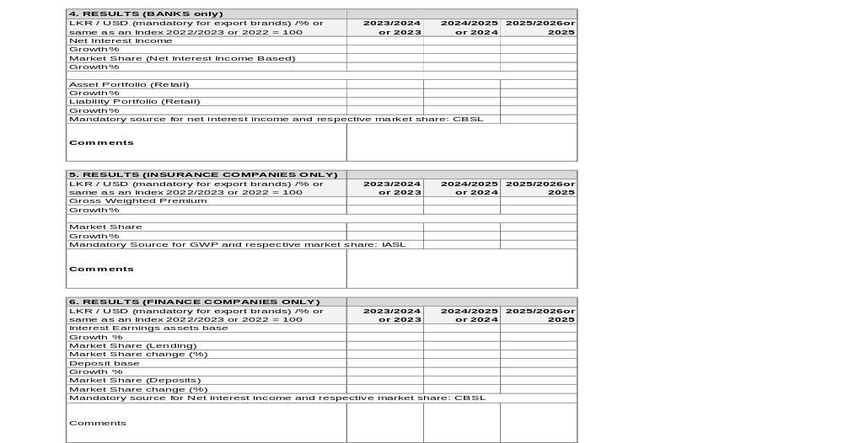

Applicant’s Declaration
I, the undersigned ……………………………………………………………………………………………………… (Full name of applicant) do hereby declare and affirm that all information herein provided by me is true and correct.
Name of Applicant:
Designation of Applicant:
Contact Number: E-mail:
Signature of applicant: Date:
Company name & address
V.A.T Reg. No:
Name of CEO of Company:
Signature of CEO: Date:
Contact Details: Rubber Stamp:
Telephone: Fax: E-mail:
Auditor’s Verification
We hereby certify that all information herein furnished in items …………………………………….. (Indicate information sectionnumbers) in the entry form in respect of …………………………….. Is true and correct to the best our knowledge and belief, as per the records maintained by the enterprise and made available for scrutiny.
Name of Auditor: Rubber stamp:
Signature:
Contact details:
Address:
Telephone: Fax:
Independent Research Verification
We hereby certify that all information herein furnished in items …………………………… (Indicate information section numbers) ………………………. in the entry form in the respect of ………………………….. is true and correct as per the research findings of studies conducted by this agency and fulfill the criteria for research findings that can be submitted for this entry.
Name of Agency: Rubber stamp:
Signature:
Contact Details:
Address:
Telephone: Fax: E-mail:

Note: If more than one auditor’s and/or research agency information is used please use copies of this page for each one of those institutions.
-END-

