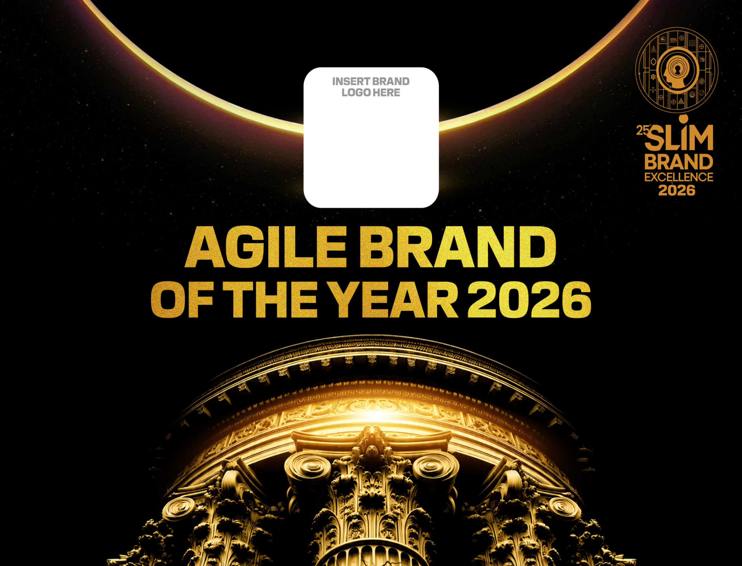

INSTRUCTIONS TO PARTICIPANTS

- Please stick to the format when responding to the questions in the entry form and ensure that you strictly adhere to the provided space allocation. (Within the box)

- Please ensure to use a font size above 10 when completing your entries.

- Please attach visuals and supporting documentation separately.

- Please ensure to include all internal company information to showcase achievements and all research information should be verified by auditors and the research agency on the last page of your entry. In addition, verification seals should be placed on the document on which data is provided.

- The complete application should not exceed 16 pages. (Excluding attachments)

- All data contained in the application must reflect a single period, either the calendar year (Jan to Dec 2025) or the financial year (1st April 2025 to 31st March 2026), shorter periods will not be accepted.

- External data such as market share, equity scores must include competitor data for comparison.

- All data submitted in the application must relate to the brand under which the application is made.
Example:
- If the brand the submission is made on behalf is “Prius” (SUB BRAND) all data and activities included in the application must relate to “Prius” (SUB BRAND) specifically and not any activities, results or data related to Toyota (CORPORATE OR MAIN BRAND).
- If the application is made for “Toyota” (CORPORATE OR MAIN BRAND), all data and activities included in the application must relate to “Toyota” (CORPORATE OR MAIN BRAND) specifically and not any activities, results or data related to their sub-brands such as Prius or Corolla.

AGILE BRAND OF THE YEAR
Entries should be submitted by brands that can evidence early identification of change, decisive action and measurable brand and business results within the year under review.

•A.1: Name and Address of Company:  •A.2: Year of Establishment of Company:  •A.3: Size of Company:  (Please mark your selection with a “X” within brackets)  ( )XS - Annual turnover Less than Rs.350 mill  ( )S - Annual Rs.351 mill - Rs. 1 bill  ( ) M - Annual Rs. 1 bill – Rs.2 bill  ( ) L - Annual turnover Rs.2 bill – Rs.5 bill  ( ) XL - Annual turnover more than Rs.5 bill  •A.4: Financial Year:  (Please mark your selection with a “X” within brackets)  ( ) January – December  ( ) April – March |  | •B.1: Name of Brand:  •B.2: Brand Custodians Name & Designations:  •B.3: Year of launch of the brand into the Sri Lankan market  •B.4: Entry Category  (specify from Main Awards or Special Awards Category)* :  •B.5: Origin of Brand : 1 – Sri Lanka 2 – International  •B.6: Size of Brand :  ( Please mark your selection with a “X” within brackets)  ( ) XXS - Annual turnover Less than Rs.20 mill  ( ) XS - Annual turnover Rs.21 mill – Rs.350 mill  ( ) S - Annual turnover Rs.351 mill – Rs.1 bill  ( ) M - Annual turnover Rs. 1 bill – Rs.2 bill  ( ) L - Annual turnover Rs. 2 bill – Rs.5 bill  ( ) XL - Annual turnover more than Rs.5 bill

C.5: Section 1 - Brand & Market Context

C.5:1.1 Briefly describe the brand, its market, target consumers and current competitive position. Please use only space given in the box)Font size not below 10.

C.5:1.2 What significant changes or challenges occurred in the market during the period under review.

C.5:1.3 What changes in consumer behavior, needs or expectations did the brand identify.

C.5: Section 2 - Monitoring and Identification
C.5:2. How did the brand validate that this was a genuine opportunity or threat rather than a short-term fluctuation? Please use only the space given in the box) Font size not below 10.

C.5: Section 3 -Speed & Agility

C.5:3.1 What action did the brand take in response to the identified opportunity or challenge? Please use only space given in the box)
Font size not below 10.

C.5:3.2 How quickly did the brand move from identifying the issue/opportunity to taking action?

C.5:3.3 What organizational processes, people or decision-making structures enabled the brand to respond quickly? Was there an instance where the brand changed or abandoned its original plan because market conditions changed? Please use only space given in the box) Font size not below 10.

C.4: Section 4 -Innovation & Adaptability

C.4:4.1 What did the brand change, innovate or introduce as a result of the market opportunity or challenge? Please use only space given in the box)
Font size not below 10.

C.4:4.2 How was the solution different from what competitors were doing?

C5: Section 5- Consumer Impact

C.5:5.1 How did consumers respond to the changes made by the brand? Please use only space given in the box)
Font size not below 10.

C.5:5.2 What evidence demonstrates that the brand’s response solved a genuine consumer need or created additional value?

C:6 Section 6 - Business Performance
C.6:6.1 What measurable business results were achieved? . Provide information of Sales Growth, Market-Share Growth, Volume Growth, Revenue, Profitability, Distribution/Penetration, Customer Acquisition, Customer retention, Digital engagement, Brand Awareness/preference, ROI Please use only space given in the box)
Font size not below 10.

C.6:6.2 What percentage of the results can reasonably be attributed to the agile initiative described?

C:7 Section 7 - Sustainability and learning
C.7:7.1How sustainable are the results? Please use only space given in the box)
Font size not below 10.

C.7:7.2 What did the organization learn from this experience?

C.7:7.3 How has the learning changed the way the brand operates today?

C.7:7.4 What systems or practices have been put in place to make the brand even more agile in the future?

Section 8 BRAND PERFORMANCE (40%)

In this section the actual performance of the brand in the market place will be assessed through the information provided by you in the application, which will be endorsed by independent auditors and research companies.

Marks in this section will be apportioned as follows;

A) Brand Health (20%)
A.1. Provide information with regard to brand equity measures; brand awareness, brand associations, loyalty, customer satisfaction etc. endorsed by research companies. (Font size not below 10)
Note: Wherever research data is presented to show a particular brand’s performance it should be substantiated by clearly stating the source duly verified by the researcher and performance should be compared against industry. For research data, please follow the research guidelines mentioned in the website/ handout provided.

B) Business Performance of the Brand (20%)

The financial results section has been divided in to different areas in order to recognize the differentiation between different service entities. Please provide relevant information in your respective areas pertaining to the last 3 years (Please use only space given in the box) Data has to be supported by audit confirmation and seal placement on each submission. Please fill ALL spaces in the tables below.

Its MANDATORY that either tables 1/2&3 or 4(for Banks) or 5 (for Insurance companies) or 6(for Finance Companies) are included in the slides presented during the 2nd round.

1. Volumes |  | 2023/2024 or 2023 | 2024/2025 or 2024 | 2025/2026or 2025
1.1 | Volume in MT/KG/LT/Units or
1.1 | Volume as an Index 2022/2023 or 2022 = 100 | 100
1.2 | Market (Volume) Share % or
1.2 | Market (Volume) share as an Index 2022/2023 or 2022 = 100 | 100
Indicate Market Share Source, ie: Independent Research/Industry publication/Import-Export Statistics or Internal estimate (Delete accordingly)
2. Value (LKR for Products marketed in Sri Lanka or USD for Exports) |  | 2023/2024 or 2023 | 2024/2025 or 2024 | 2025/2026or 2025
2.1 | Value in LKR / USD (mandatory for export brands) or
2.1 | Value as an Index 2022/2023 or 2022 = 100 | 100
2.2 | Market (Value) Share % or
2.2 | Market (Value) Share as an Index 2022/2023 or 2022 = 100 | 100
Indicate Market Share Source, ie:Independent Research/Industry publication/Import-Export Statistics or Internal estimate (Delete accordingly)
3. Brand Profitability |  | 2023/2024 or 2023 | 2024/2025 or 2024 | 2025/2026or 2025
3.1 | Gross profit/margin in LKR/USD (Absolute terms) or
3.1 | GP as an Index 2022/2023 or 2022 = 100
3.2 | Gross profit/margin % or
3.2 | GP as an Index ie : 2022/2023 or 2022 = 100
Export Brands need to indicate value in USD

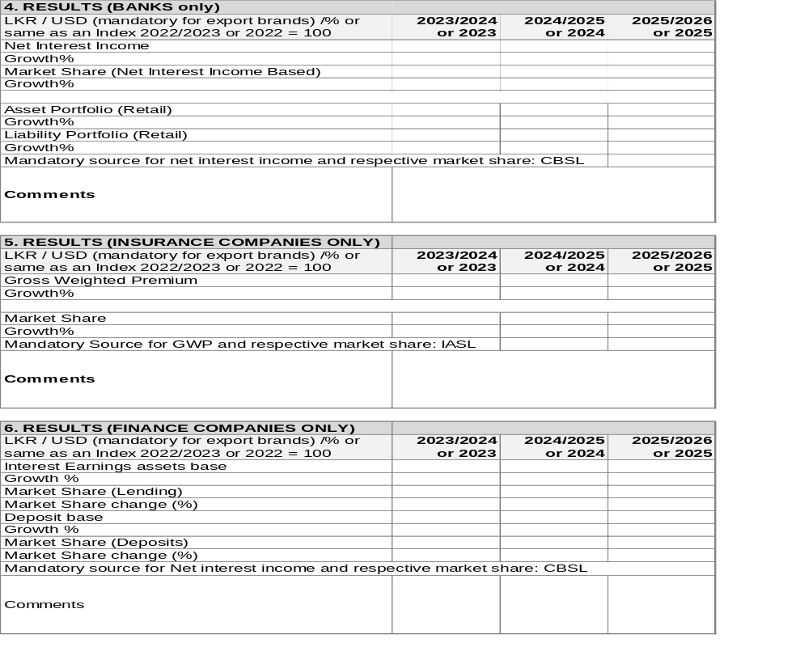

Applicant’s Declaration
I, the undersigned ……………………………………………………………………………………………………… (Full name of applicant) do hereby declare and affirm that all information herein provided by me is true and correct.
Name of Applicant:
Designation of Applicant:
Contact Number: E-mail:
Signature of applicant: Date:
Company name & address
V.A.T Reg. No:
Name of CEO of Company:
Signature of CEO: Date:
Contact Details: Rubber Stamp:
Telephone: Fax: E-mail:
Auditor’s Verification
We hereby certify that all information herein furnished in items …………………………………….. (Indicate information section numbers) in the entry form in respect of …………………………….. Is true and correct to the best our knowledge and belief, as per the records maintained by the enterprise and made available for scrutiny.
Name of Auditor: Rubber stamp:
Signature:
Contact details:
Address:
Telephone: Fax:
Independent Research Verification
We hereby certify that all information herein furnished in items …………………………… (Indicate information section numbers) ………………………. in the entry form in the respect of ………………………….. is true and correct as per the research findings of studies conducted by this agency and fulfill the criteria for research findings that can be submitted for this entry.
Name of Agency: Rubber stamp:
Signature:
Contact Details:
Address:
Telephone: Fax: E-mail:
Note: If more than one auditor’s and/or research agency information is used please use copies of this page for each one of those institutions.
-END-

